A guide to data clinic

25 Feb 2022

Conor Foley, Dan Stein & Tim Bonnici

# What is data clinic?

Data clinic is an initiative to help clinicians get data from Epic. This is to improve the ease and speed of audits, QIPs and service evaluations we perform in critical care.

UCLH ICU has a dedicated team of Business Intelligence Partners who work to service these requests. The data clinic aims to streamline the process of getting this data, using two approaches: we aim to understand the clinical question you are trying to answer, and to show you what data is available to retrieve from Epic. Then we aim to provide that data for you, as quickly as possible.

# How do I access it?

Prior to now, the requests have been ad hoc. Please feel free to speak to any of Tim, Conor or Dan about your project on the unit. We may be able to help your collection in a way you haven’t seen.

Please register your interest at the following link: tinyurl.com/someletters. Then we will be in touch to arrange a screening meeting.

# What is the process?

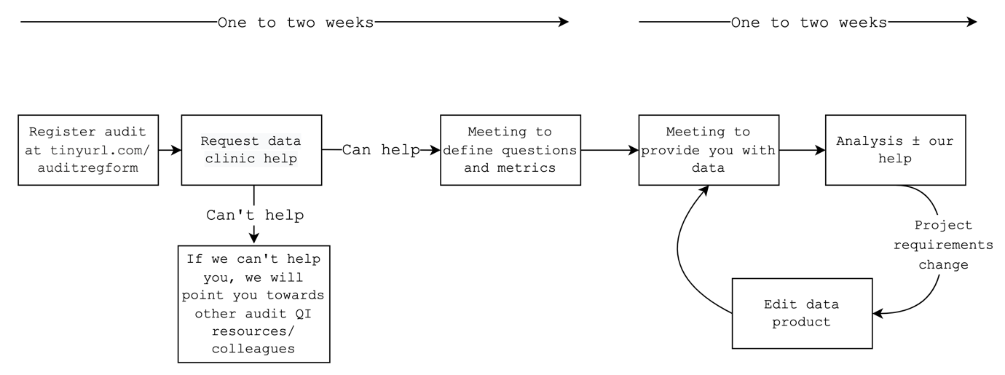

# What is required of me?

You must first have registered your audit at <https://tinyurl.com/auditregform>.

Our aim is to improve your project. In order to compile data for you, we need to understand your aims/questions clearly. This requires some pre-thought to distil down to specific questions what data you want. No analysis or data skills are required, and we are happy to tailor our product to your needs.

# Where can I get more information?

Please speak with any of us directly on the unit, or via email below. See the Audit & QI Teams Channel for information on past and current projects.

Tim – [t.bonnici@nhs.net](mailto:t.bonnici@nhs.net)

Dan – [dan.stein@nhs.net](mailto:dan.stein@nhs.net)

Conor – [conor.foley@nhs.net](mailto:conor.foley@nhs.net)